**PROJECT M: Final Report**

Work presented to Mr. David Knox

In the class of GNG 2101A – Introduction to Product Development and

Management for Engineers

By Group A2

University of Ottawa

December 9, 2017

**Table of Contents**

**Abstract** **3**

**Introduction** **4**

**Research and Benchmarking** **5**

**User Need Identification** **7**

**Problem Statement:** **9**

**Possible Design Solutions** **9**

Design Solution 1: Tilting platform 9

Design Solution 2: Wheelchair attached piston 10

Design Solution 3: Gyroscopic Wheelchair 11

Design Solution 4: Motor Tilting 12

**Design Criteria** **14**

**Target Specifications** **17**

**Prototyping** **19**

Prototype 1 19

Prototype 1.5 22

**Final Design** **24**

**Constraints, Risks and Regulations** **25**

**Prototype Strategy and Results** **27**

**Conclusion** **28**

**Appendices** **30**

A. Engineering and Mathematic Calculations 30

B. Budget 33

C. Tables, Charts and Miscellaneous 36

References 38

# **Abstract**

Wheelchair bound patients at Saint-Vincent Hospital (SVH) encounter the physical problems when remaining seated for long periods of time. Patients develop blood circulation problems and stresses joints and bones which can only be relieved by reclining or laying down in a horizontal position. SVH required assistance from our team to design a solution to solve the problem at hand. Our mission is to designing a cost-efficient, safe, easy to use tilting device for multiple wheelchairs. Several low-cost prototypes were created for proof of concept and receive feedback from the patient/client to better the design process. Due to material availability, costs constraints and time, the prototype was built out of lumber rather than metal as originally planned. The final prototype was successfully completed before the anticipated delivery date with only minor design flaws.

# **Introduction**

Many patients at St-Vincent's Hospital use manual wheelchairs as a form of transportation. Usually, they will spend multiple hours at a time in the wheelchair. After a while, it can begin to feel painful and so it is necessary to tilt the wheelchair backwards so that the pressure on the wheelchair users bottom may be relieved and blood circulation may be promoted. Manual wheelchair users require the aid of a nurse or volunteer in order to get their chairs to tilt. However, aid is not always immediately available for the patients. It is for that reason that our client, Bocar, was interested in a tilting mechanism that was fully automated and would allow manual wheelchair users to tilt without any outside assistance.

We came up with the Tilt so that we could provide a solution to not only one user, but the entire hospital. Our tilting platform can be used by multiple users with multiple different wheelchairs. It is fully automated and can be readily accessed by whoever needs to use it. Due to the fact that is a separate entity from the wheelchair itself, it does not modify the frame of the wheelchair in any way. Our design may be used by hospitals, senior homes, dentistry clinics, essentially anywhere that it is needed. From a financial standpoint, not only will patients save money on not spending money on ridiculously expensive automated wheelchairs, but the hospital can just invest in one project and nurses can spend their time dealing with more pressing matters.

With the Tilt in place, any manual wheelchair user could simply go to a room and tilt their wheelchair without any assistance. Due to this, it works for multiple users with varying physical capabilities, which we believe is incredibly important. Also, it is the most cost efficient solution on the market, with automated wheelchairs going up to about 4000$ and other solutions coming in close to that as well. Our product would only cost about 2000$ and would be a better investment for hospitals in the long run.

# **Research and Benchmarking**

There are many makes and models of automated tilting wheelchairs available on the market, however very few are within what most people would consider an “acceptable” price range. The simple non-automated tilting wheelchair costs $700-$1200, while an automated version of that wheelchair as seen below (figure 1) sits around $4,000 and are difficult to find in Canada. There is one product that has a different approach to the tilting wheelchair, and that is to have a device that tilts the entire wheelchair. The “Versatilt” (bottom right) allows any normal sized wheelchair to be rolled onto it and then reclines the client in the comfort of their own wheelchair. As they are the only product in the market, they do not post the cost of their product and will not respond by email with the price, though it can be assumed that the versatilt is quite expensive as an automated wheelchair starts out at $4,000. While the last two of these devices follow the design criteria, they are both over budget by a minimum of 4000%.

The non-automated tilting wheelchair is closest to the budget, is aesthetically pleasing, and is both comfortable and easy for the client to use. Unfortunately it fails one of the the key needs, automation. As the main purpose was an automated wheelchair that doesn’t require a nurse to tilt them, this design doesn’t work.

The automated electric wheelchair is vastly over budget, but does fix all of the needs that the client requires. The only downfall with this product, other than its price, is its size and the fact that it can not be done by modifying an existing wheelchair as the product has to be built specifically for this automated tilting in mind. The automated wheelchair does do very well in the job of titling a individual anywhere and anytime they want with just the push of a button. This type of portability is ideal.

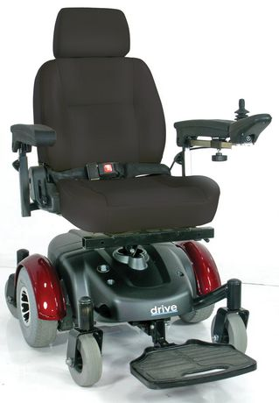

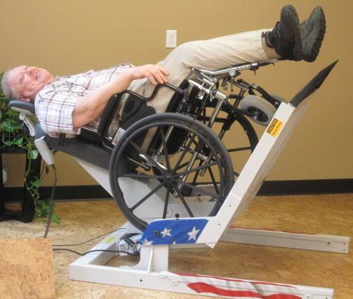

Figure 1: Automated electric wheelchair Figure 2: Versatilt

Versatilt (figure 2): This product satisfies all of the required needs, except for the price. As a bonus benefit, it can be placed in a common area and when the client is not using the device, another client would be able to use it. This maximizes the amount of benefit that the hospital gets for having such a product. While the problem gives to us required only being able to tilt a single individual, from the information we gained from Bocar, this problem is not confined to one person. Many people at the hospital all suffer from the problem. Due to this design being able to solve all of our needs, in addition to be able to satisfy some of the points that Bocar said, we believe that our design should be based off of this product.

Jan’s article (as cited in Jan, Jones, Rabadi, Foreman & Thiessen, 2010) looks at the effects of reclining angles and skin perfusion (good skin perfusion correlating to good blood flow). They found that the peak increase in skin perfusion was at 35 degrees, while angles less than 25 had little to no difference. This is a major find as this increased skin perfusion drastically lowers the patients risks of getting pressure sores, which in themselves greatly reduce the patient’s quality of life. In a similar study, Lacoste and his associates (as cited in Lacoste, Weiss-Lambrou, Allard & Dansereau, 2003) found that tilting to angles between 25 and 45 degrees allowed for better kyphotic posture (curvature of the spine), improved respiration, and reduced fatigue, among other things.

# **User need identification**

From the project background given to us it was obvious that we needed our device to be both automatic and safe so that a patient would be able to have improved blood flow and reduced stress on their body by tilting themselves back whenever they need to. As we were working with many elderly clients the device would have to be simple enough to use, as well as able to help users of multiple differing physical capabilities.

During our client meetings with Bocar, he brought up a couple of new points we added to our list of needs. Bocar told us that when a patient was successfully able to get a nurse to be able to tilt them, they were often trapped like that for long periods of time. During this time some of them would try to tilt themselves manually and could end up injuring themselves. He said that not only was this injuring a problem, but the nurses were wasting a lot of time tilting the users when they could be administering to other patients needs. This reinforced our need to create a automated and simple to use system that would not just help one patient, but everyone within the hospital. We were lucky enough to meet a few hospital patients during our first visit, who mentioned that some of their concerns were the price of current automated solutions. To pay over $4000 to have the opportunity to tilt backwards was too much for some of the families of these patients to handle.

From our research we understand that it is important for us to get the optimal range for out tilting platform of between 25-45 degrees to reduce the stresses on the body and decrease the likeliness of getting pressure sores.

We have translated the main needs of our customer into prioritized list of solution requirements:

|  |  |
| --- | --- |
| **Priority** | **Need** |
| **1** | Device must be safe |
| **2** | Increase the quality of life of the user |
| **3** | Automated |
| **4** | Allows for all types of users (physical and mental states) |
| **5** | Slowly tilts the user |
| **6** | Tilts the user to the desired degree |
| **7** | Accommodates long uses (comfortable as well) |
| **8** | Costs less than $100 |
| **9** | Looks sleek and appealing |
| **10** | Lasts a minimum of 5 years of continuous use |
| **11** | Takes up as little room as possible |
| **12** | Is easily repairable |

# **Problem Statement:**

“For continued health and comfort of our clients, a tilting system is needed that would allow patients to independently tilt themselves whenever they need to. This device must be safe, easy to use, and work for people of differing physical capabilities.”

As our project is about improving the lives of our user, we believe that above all else their health and comfort is our number one concern. To effectively increase their quality of life, we had to make sure that our product was a safe way for anyone to be able to independently tilt themselves. As we were working with clients in a hospital setting, we had to ensure that our product was intuitive enough that multiple people of differing physical and mental capabilities would be able to use it.

# **Possible Design Solutions**

We generated four Design Solutions:

* Tilting Platform
* Wheelchair attached piston
* Gyroscopic Wheelchair
* Motor Tilting

## **Design Solution 1:** Tilting platform

The basis for this idea is to have a platform that the user is able to wheel onto and then be tilted. This sturdy platform will have a pivot that the tilting device will connect to. A small hydraulic will power this tilting mechanism, this way the person is in a secure device that anyone is able to use. Having one device that is attached to a user is a wasted cost because it increases the time that the product will not be in use.

|  |  |
| --- | --- |
| **Advantages:**   * Easy to use * Very safe and sturdy * Much lower risk of injury if a malfunction occurs * Able to tilt a large number of different wheelchairs * Multiple user can use it during the day, thus increasing the amount of people that one device can help | **Disadvantages:**   * Product is heavy * The user has to go to one pre-designated spot to tilt * More costly of a design * Takes up more space * If being able to tilt in multiple areas is needed, client will have to buy multiple devices |

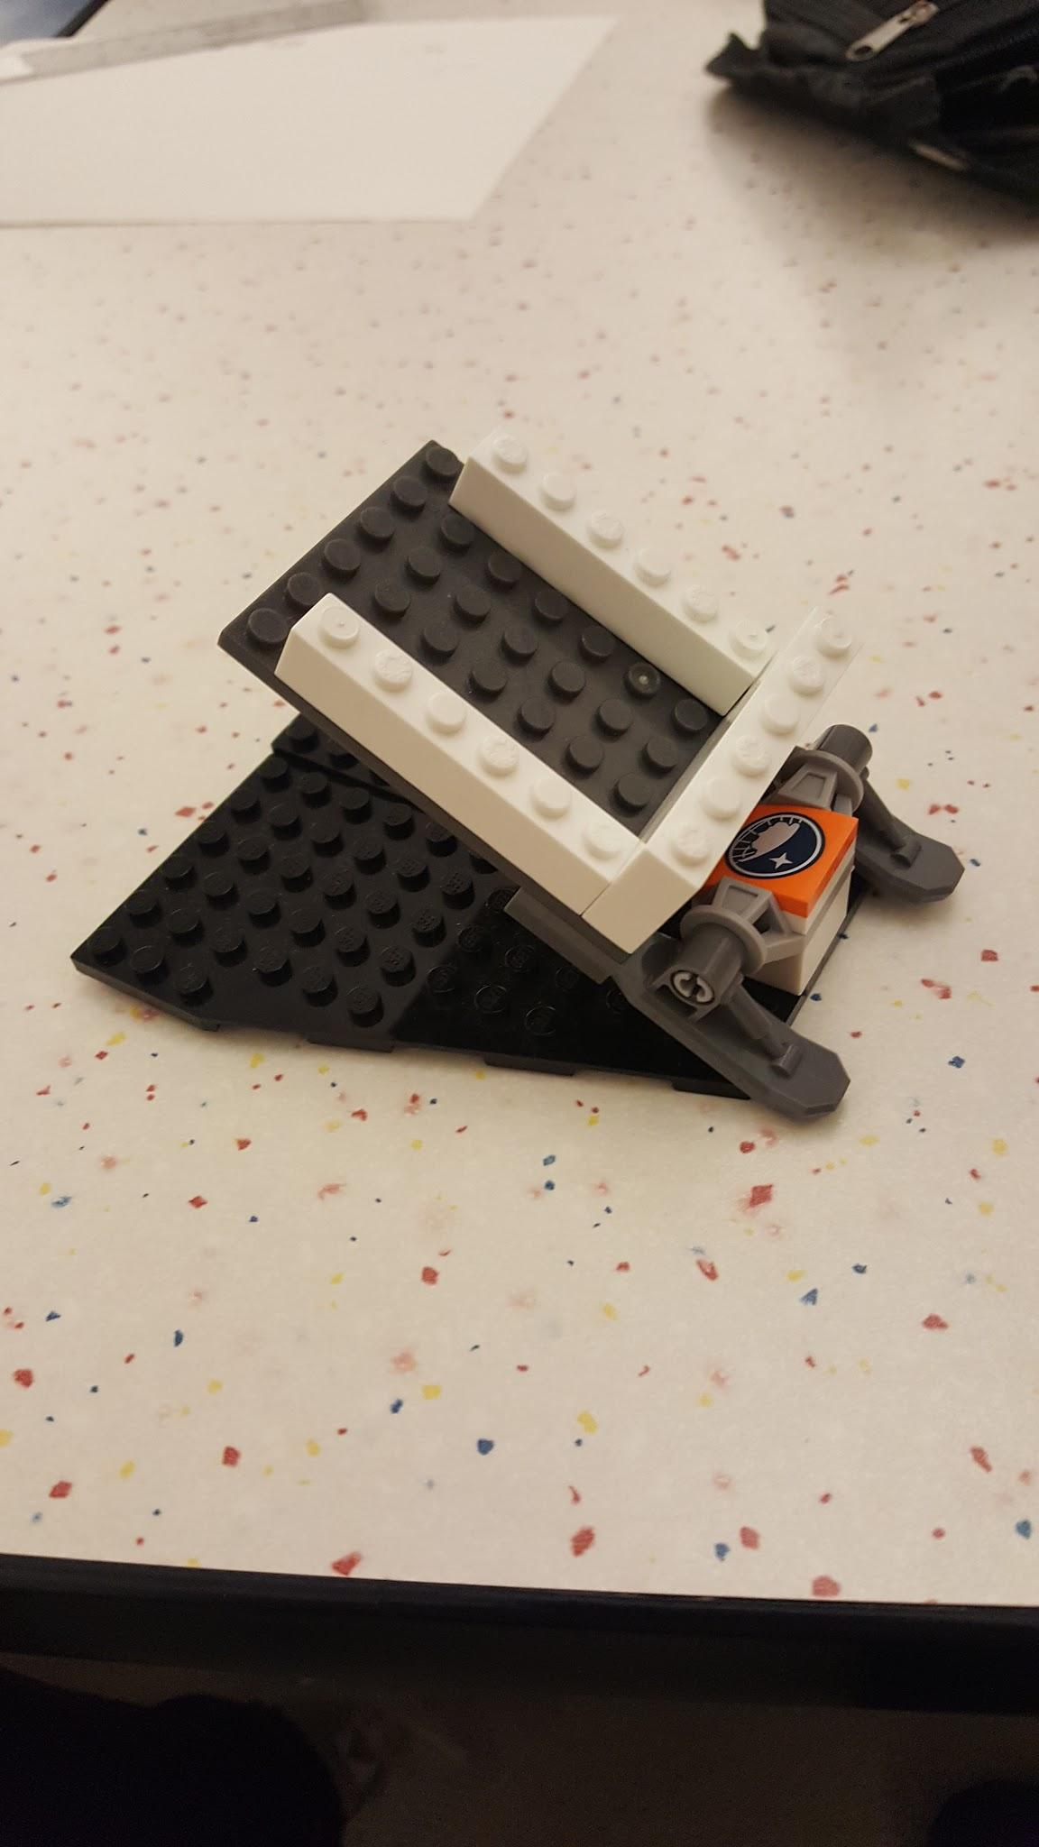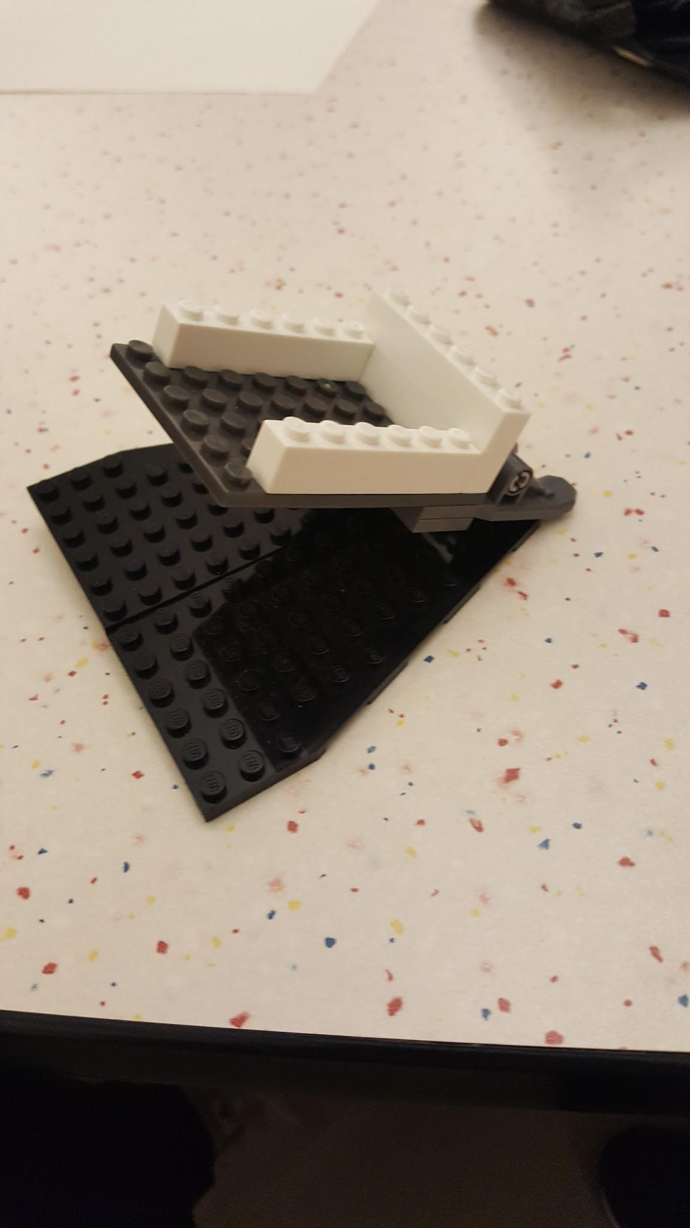

## **Design Solution 2:** Wheelchair attached piston

Behind the wheelchair, a large metal box would attached to the frame with adjustable brackets. The apparatus would have an extra set of wheels attached behind like training wheels on a pedal bike. The metal box would have an operated electric motor that operates a piston through a high capacity battery. The extra weight of the motor and piston would cause the wheelchair to fall back naturally. Depending on the placement of the battery, the battery can also be used to tilt the wheelchair in our favor and hence relieve stress on the motor. The piston would be directly connected to the training wheels that would extend and retract thereby tilting the wheelchair. The electric motor. It would be operated by a switch.

|  |  |
| --- | --- |
| **Advantages**:   * Fewer parts * Versatile as to where the client can tilt. * No modification that could compromise to the integrity of the wheelchair | **Disadvantages**:   * Weight of motor, battery and extra wheels could make it hard to maneuver and restrict mobility * Complex attachment mechanisms * Balancing weight distribution could be problematic |

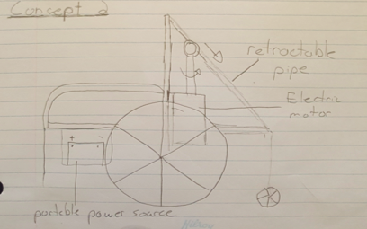

## **Design Solution 3:** Gyroscopic Wheelchair

This design utilizes main concept of a gyroscope. With massive wheels and a seat attached to an inner mechanism incorporated within these wheels, we can balance comfort and usability. With the control box, you can move in any direction you desire as well as readjust your degree of tilt at any time.

|  |  |
| --- | --- |
| **Advantages**:   * Futuristic and advanced design * Ability to tilt at any time while moving | **Disadvantages**:   * Bulky, large design which may cause problems with doorways and such * A long manufacturing and assembly process * A lot of time must be invested to ensure maximum user security and safety * Does not meet most of our requirements |

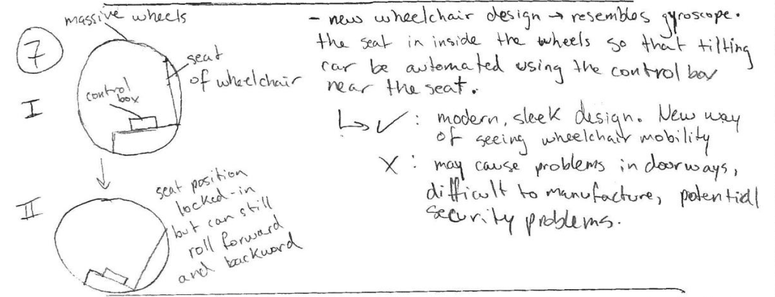

## **Design Solution 4:** Motor Tilting

An automated system in which there is a motor attached to the bottom of the wheelchair which will allow the wheelchair to tilt using controls present at the armrests. Supports would have to be added to the back of the wheelchair in order to support it when tilted. A timer is also present in order to inform the patients when they should be tilting and for how long.

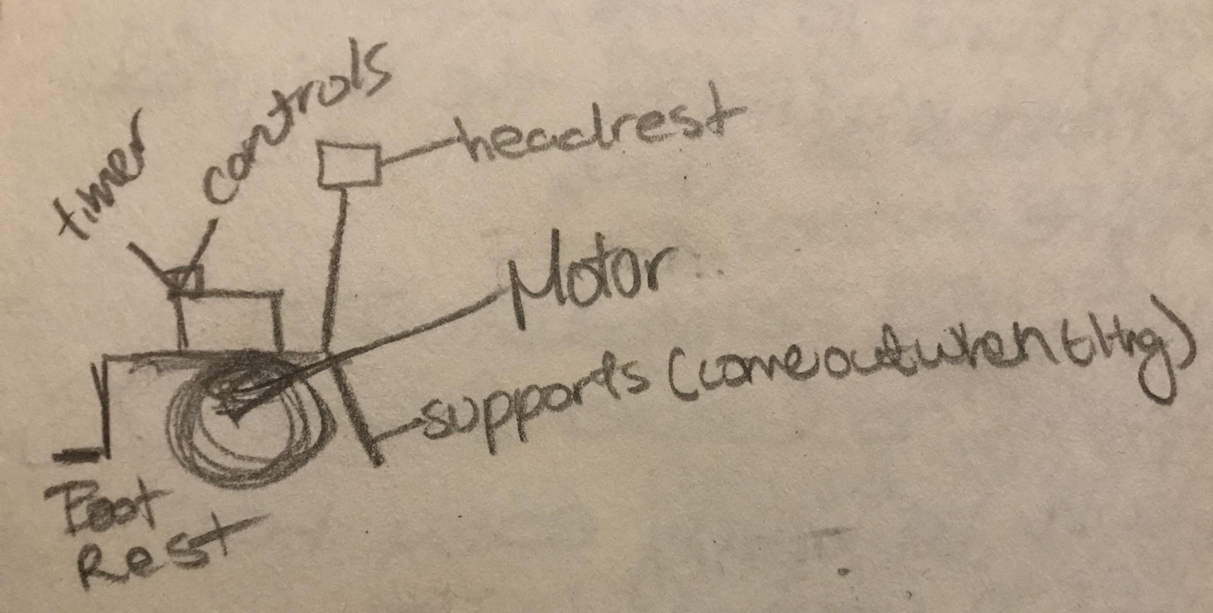

|  |  |
| --- | --- |
| **Advantages:**   * Easy to use * Patient would not be required to go to a specific area * Timer allows them to know when to tilt | **Disadvantages:**   * Very hard to design without compromising the original frame of the wheelchair * Could add a lot of bulk to the chair itself * Wouldn’t be aesthetically pleasing * Would need constant access to a wheelchair in order to work on project (which we may not have) * Only allows use by one user |

As the problem was very open ended in how we could solve it, we ended up having quite a few very different concepts that were unable to mesh well together. Unfortunately this meant that we were unable to integrate things from the unused designs into our main design. We have decided to go with the tilting platform as it does a great job fulfilling all of the criteria and has the highest rating, as well as being the most stable/safe, and being able to help multiple people with one device. However, we will not be using a hydraulic motor like the original design asked for as they are too expensive for our budget, and other just as safe and reliable motors can be found. 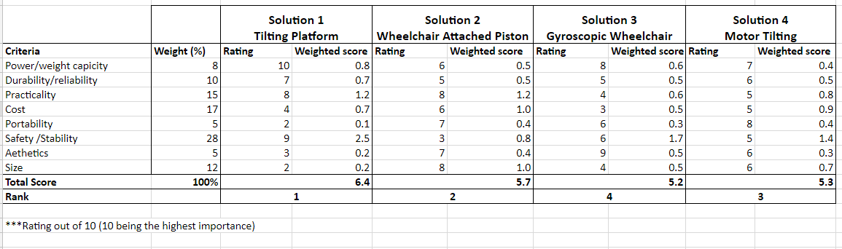

# **Design Criteria**

Our client, Bocar, is interested in an automated tilting Wheelchair. That’s why we decided to create a product that’s simple to use. We chose the first option based on our design matrix as the first design has the highest weighted score. This design will be beneficial as it will be easy to use, require no alterations to the original frame of any wheelchair, it’s tilting can be slow and controlled, and can easily reach 45 degrees. Also, it may be used by multiple users. In fact if executed correctly, it will meet all design criteria, including the optional ones. This project does not require constant access to a wheelchair, which we probably will not have and so it is ideal. The product may be difficult to move due to its weight but this is an acceptable drawback as the integrity of the wheelchair’s frame will not be compromised and the largest amount of people can be helped with only one device.

Our design criteria leaves us fairly restrained in the amount of solutions to our problem statement because of the sheer complexity and needs of the clients. The most important element is the safety and wellbeing of our clients therefore many of the mandatory requirements revolve around that aspect. Usability is also incredibly important as the point of this device is so that patients can use it without the assistance of another person. The optional features of our design are simply bonuses we can add once we have effectively solved our problem statement. We came up with an idea of using the product with either a button the patient may use or, a touchscreen device that includes a timer. The purpose of the timer is to promote better blood circulation. For example, after 5 hours of sitting on the Wheelchair, you will hear a beeping sound. The button to tilt the wheelchair is intended to be used by older patients that don’t know how to use a touchscreen device. And, the touchscreen device with timer is intended to be used by younger patients who are familiar with touchscreen devices.

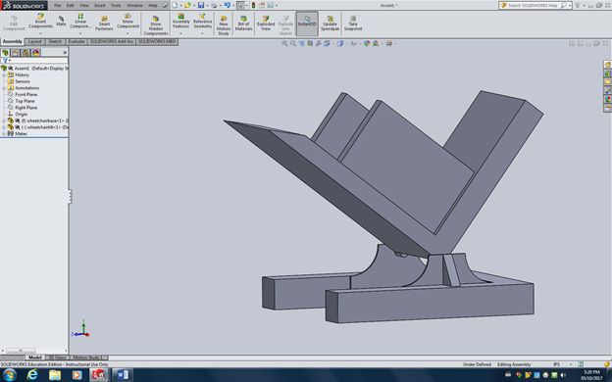

Based on the information we collected from our previous project deliverables. We have narrowed down our mandatory and optional design criteria.

**Mandatory:**

* Design must tilt to a minimum 45 degree angle
* Slow/controlled tilting
* Design cannot compromise the integrity of the wheelchair
* Easy to use operation
* Fail-safe to prevent dangerous tilting levels
* Powered by electricity
* Minimum of 600lb weight capacity
* Maximum design weight of 250lbs

**Optional Features:**

* Touchscreen device with timer (purpose of the timer is to promote better blood circulation).
* Electronic on-screen LCD display.
* Aesthetically pleasing
* Durability of 5 years
* Quiet
* Portable/movable
* Less than 1.5m2 area design

|  |  |
| --- | --- |
| **Need #** | **Need Description** |
| **1** | The device can frequently be in use for long sessions. |
| **2** | The device allows slow and safe tilting. |
| **3** | The device accommodates at least 90% of the wheelchair designs on the market. |
| **4** | The device looks sleek and appealing. |
| **5** | The device will take up as little room as possible. |
| **6** | The device lasts a minimum of 5 years of continuous use. |
| **7** | The device is easily repairable. |
| **8** | The device allows anyone to be able to use it. |
| **9** | The device costs $100 or less. |
| **10** | The device tilts to a low enough angle |

# **Target Specifications**

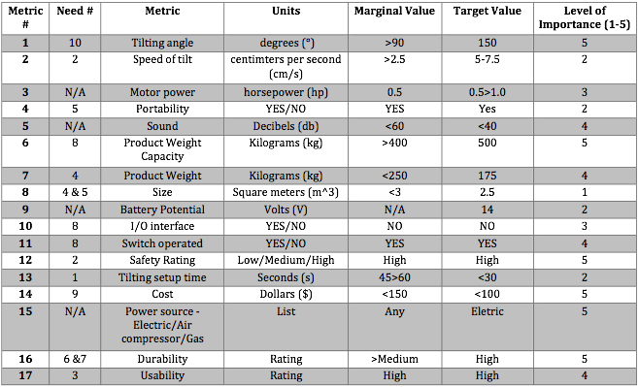

# **Prototyping**

## **Prototype 1 & 1.5**

The mechanical aspect of tilting the platform from the body of the frame requires an electric motor with sufficient power to push up the platform and its contents. The mechanism we designed will use an electrically powered scissor jack to move the platform upward. According to our mathematical analysis, the Sledjack 12 volt automated jack has a capacity of 907kg capacity with an 11 inch lifting range which will provide the required power.

To test the tilting mechanics, we designed a basic no-cost prototype with simple materials. The idea is having the scissor jack behind the platform that would essentially pull back the platform with the wheelchair on it to an almost horizontal position.

**Position 1**



**Position 2**



**Scissor jack in extended position. Scissor jack in retracted position**

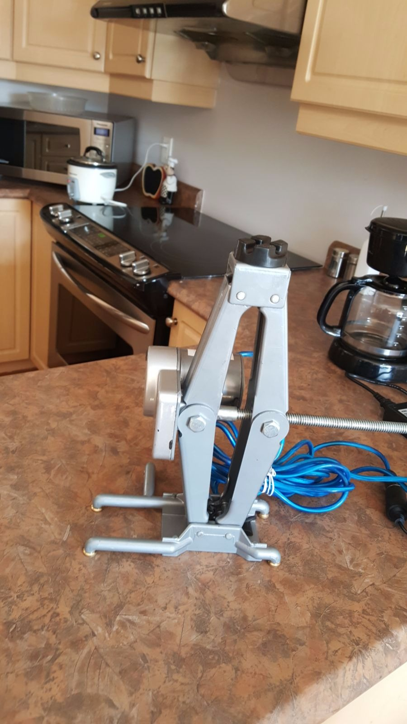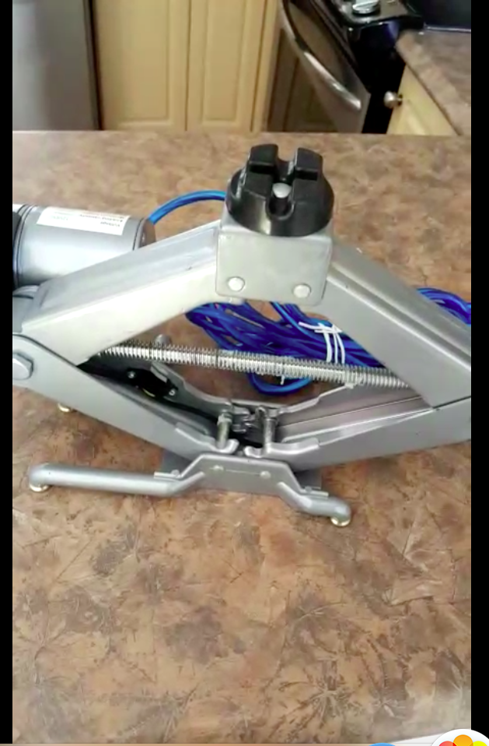

In demonstrating the proof of concept, we simply placed the scissor jack leverage point in at the top of platform. However, the official design will be placed at precisely 11.9 inches from the bottom of the platform. This was determined through mathematical calculations by taking into consideration load, tilting range of motion and optimal leverage points (see calculations above). Here is refined computer generated model of the platform with the positioning of the scissor jack.



The second major concept that we needed to test is the pivoting mechanism. The platform that will be tiling back and forth will be attached to a U shaped frame. The method in which the platform and pivots from the frame is crucial because it needs to be nearly frictionless and strong enough to not bend under pressure. This will be achieved by inserting an steel ¾ inch rod through the holes in the platform as shown in the following computer generated images.



Within each of the four holes in the platform, a metal bearing fitting the size of the steel rod will be inserted to provide frictionless movement. The rod will then be anchored securely to the frame at both end points to prevent horizontal slipping. To test this concept, we designed a basic wood prototype of the frame and platform attached in the manner described above. A rod was placed through the platform and into the frame. The platform tilts back and forth easily without any concern. The rod was placed near at the very bottom edge of the platform which allowed for easier tilting. Through this prototype we have determined that the lower we place the rod, the easier it will be to leverage the load on the platform. The following images and video sum up the essentials of the pivoting mechanism test.

Youtube Video: <https://youtu.be/mzxZDCErKwU>

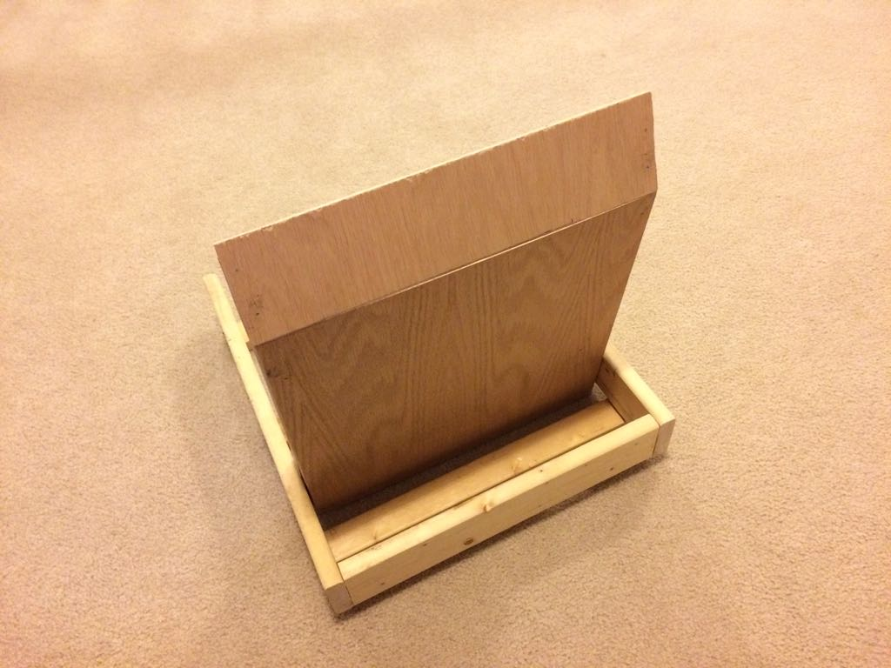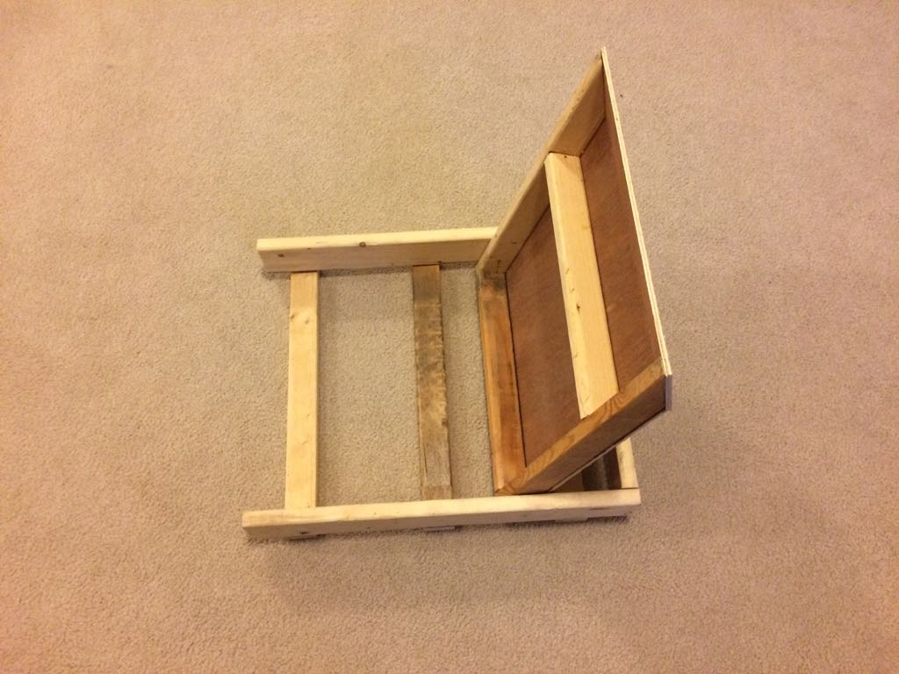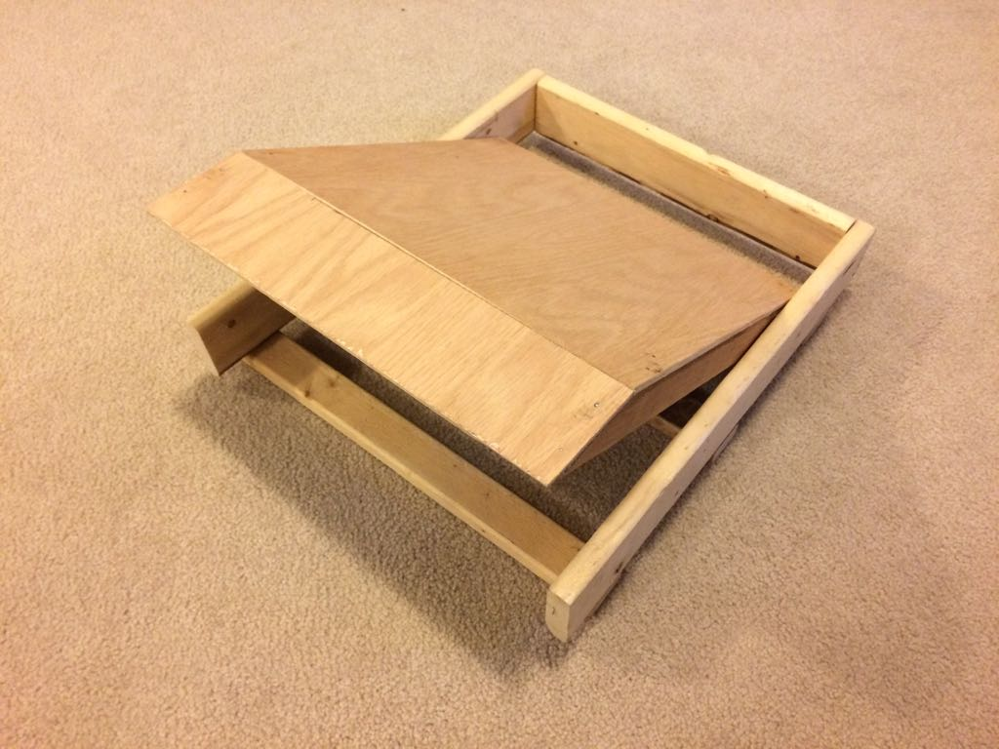



# **Final Design**

Our Final Prototype is a “proof of concept” made out of wood. Our product is safe, easy to use and fully functional. Mix of a medium and high fidelity prototype:

* Fully functional, interactive, very detailed, and much more time-consuming to build
* The final stage of the prototyping process that provides the closest representation of the final solution with all the expected functionalities
* Used to analyze the functionality, visual appearance, and for “user experience” purposes. This type of prototype has most of the expected features and functionality of the final product

But has a certain medium fidelity since certain aspects of the design and the mechanism aren’t what we’d use if we had the proper budget and time to make the final design out of metal.

The whole wooden model consists of 4 parts: the platform, the U-shaped frame, the tilting mechanism, and the pivoting axle. To build our platform, we built two wooden frames with OSP board and 2x4s. The one used for the base of the platform was 4’x4’ and the one used for the backing of the platform was 4’ x 4’. We secured these two together using a large number of screws and two 5.6’ 2x4s as extra support running along both sides of the platform diagonally. Our U-shaped frame was simply made up of three 6’ 4x4s screwed together securely. In addition, two diagonally cut 4x4s were added in the corners of the frame for added structural integrity.

The mechanical aspect of tilting the platform from the body of the frame required an electric motor with sufficient power to push up the platform and its contents. The mechanism we designed used an electrically powered scissor jack to move the platform upward. According to our mathematical analysis, the *Sledjack* 12 volt automated jack has a 907 kg capacity with an 11 inch lifting range which will provide the required power. It is placed at a distance far enough to be able to create an isosceles triangle and recline the platform up to 45 degrees. A large wheel is welded to the top of the *Sledjack* which will allow the the platform to tilt smoothly, as it runs along a sheet metal track secured to the underside of the the base of the platform, while the jack itself can stay firmly secured to the ground.

The pivoting axle is the final piece of the puzzle that allows everything to move. Using 4 metal elbows with a 135 degree inner angle, we are able to connect the platform to our U-shaped frame. At the ends of each of these elbows and on elevated mounts placed on the U-shaped base can be found ¾” ball bearing mounts which will house and be used to pivot around our 72” steel rod. These 4 elbows are attached and distributed evenly to the base part of the platform to allow the least amount of concentrated stress applied to our rod while tilting. Once all the bearing mounts are aligned, we slide the rod through them all and the device is now completely assembled.

# **Constraints, Risks and Regulations**

Our main concerns with this prototype was time, costs and engineering mechanics. Buying and purchasing all the necessary materials quickly enough without causing any unnecessary delays in prototype building was a difficulty. Our team had very different schedules and meeting on weekly basis for extended periods of time proved difficult. Using basic communication programs such as WhatsApp was essential in maintaining open and quick communication. Proper planning using the Gantt system also allowed us to assign tasks and ensuring each team member is delivering on current deliverables and objectives.

Since the comprehensiveness of the design, going over our budget was also of real concern, As per our proposed Bill of Materials, we are already topped on the amount we can spend. Additional expenses will have to be justified appropriately. Additionally, this does not include any miscellaneous expenses we might incur. With most design projects, there are often unforeseen costs. The cost of a full scale model using a metal frame will not fit into the allotted budget of 100$. Thus, we have determined that it was better to do a full scale model out of wood, just to demonstrate the functionality of the design.

Lastly, several of the mechanism involved in lifting a heavy platform at an angle involves many stresses on various parts of the design. Several calculations were taken into account when placing and securing the electric jack (please view Appendix B for calculations).

Several regulations, both mandatory and optional, apply in the context of this design. The three major are provided here:

* International Organization of Standardization (ISO) in particular Part 5, 7 and 16 refer to the dimensions, postural support and weight of the manual wheelchairs. Our design must keep in mind these specific factors when building and taking into load capacity
* The Ontario Building Code on Accessibility Standards Act & the Canadian Mortgage and HOusing Corporation (CMHC) has a mandatory requirement for wheelchair accessible buildings to possess a slope of no more than 12 inches long by 1 inch in height so wheelchairs can move up a ramp. This standard does not directly apply to our design. However, when building our platform, a ramp will need to be constructed for using the platform
* The T[echnical Standards and Safety Act of Ontario](https://www.ontario.ca/laws/statute/00t16) has a mandatory requirement for any device that moves a person with a disability must be approved by this regulation. Our product must meet their standards in order to be sold and used by the general public. It must be certified by an inspector.

# **Prototype Strategy and Results**

Our tilting wheelchair design is complex and involves multiple working components to work in synchronous in order to provide safe and reliable tilting. That’s why the prototypes helped us, especially during the client meetings where we received a lot of useful information from Bocar and Phil. Low fidelity models allowed our team to:

* Develop an idea or set of ideas rapidly
* Iterate, test, evaluate, and validate many assumptions about the proposed solution in short span of time with limited resources
* Explore different ideas and discuss the usefulness of various possible solutions.

# **Conclusion**

To conclude, most patients at Saint-Vincent Hospital use manual wheelchairs for extended periods of time, that’s why we created *TILT!* (The Wheelchair Tilting Device). Instead of making the product out of metal, we created a proof of concept made out of mainly wood to relieve stress and to promote better blood circulation. Our device is universal, allows for multiple users of differing physical capabilities to benefit from it, and is the most cost-efficient solution currently available.

The takeaways from this process relates directly to the constraints we identified early on in the design process. It is absolutely essential to take into account any external forces in design plans before final prototyping begins. We underplayed many of the horizontal forces exerted on our electric jack which caused an increase in materials for additional structural support. For time, we may have been overly ambitious in determining how much time a task would take to complete. For the most part, solving certain engineering problems took longer than expected which pushed our design plans back. In terms of cost forecasting, properly creating a comprehensive design plan would have allowed to budget accurately. Forgetting simple materials or supports such as screws, bolts, and bearing mounts would have saved us valuable time in purchasing the additional materials. In hindsight, if we had planned with more accuracy from the beginning, spent less type building low fidelity prototypes and started final prototyping earlier we would expect a much more comprehensive and high quality final product. In summary, the lessons and experiences we learned are extremely valuable. We hope to apply the skills we learned in our future projects and academic careers.

# **Appendices**

## A. Engineering and Mathematic Calculations

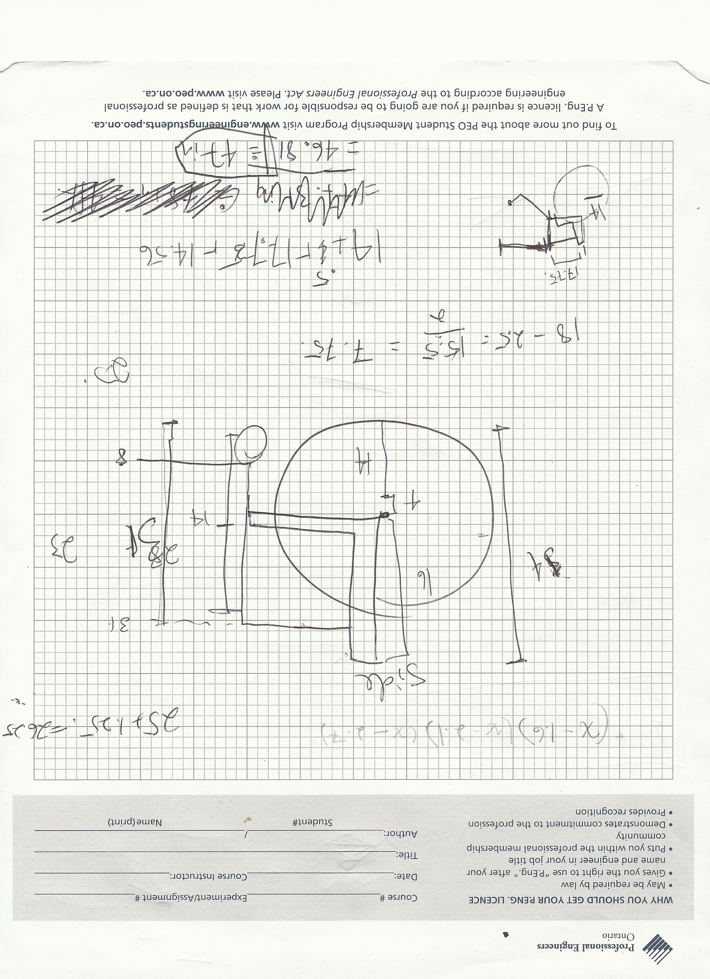

## **B. Budget**

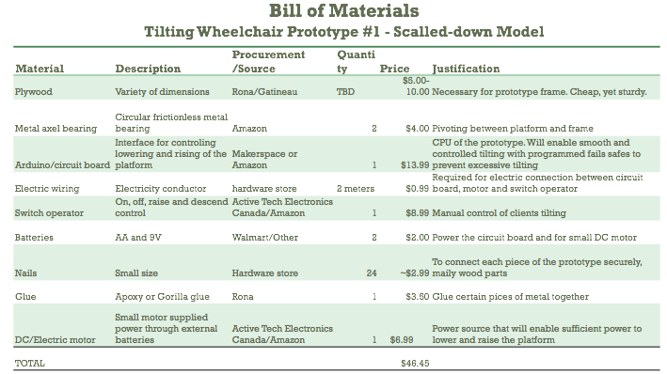

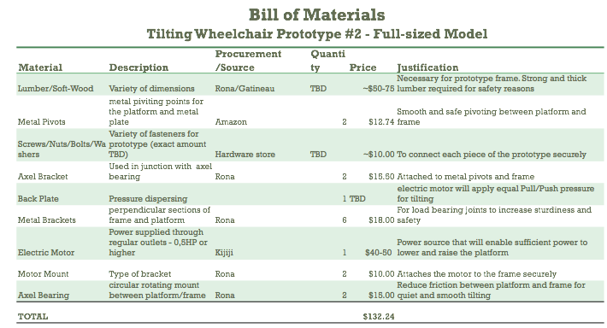

## **C. Tables, Charts and Miscellaneous**

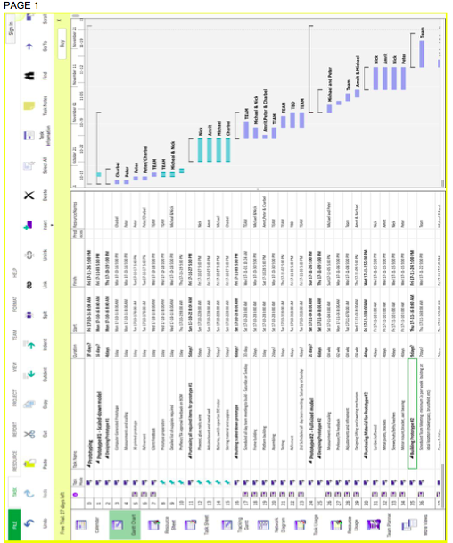

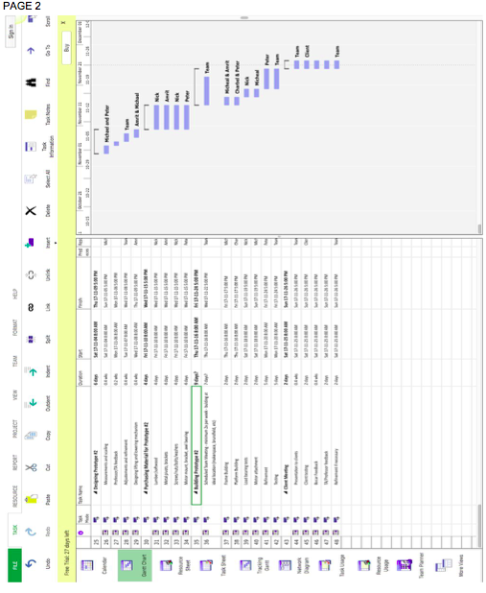

## 

## **D. References**

Jan, Y., Jones, M. A., Rabadi, M. H., Foreman, R. D., & Thiessen, A., (2010). Effect of wheelchair tilt-in-space and recline angles on skin perfusion over the ischial tuberosity in people with spinal cord injury. *Archives of Physical Medicine and Rehabilitation, 91*(11), 1758-1764.

Lacoste, M., Weiss-Lambrou, R., Allard, M., & Dansereau, J. (2003). Powered Tilt/Recline Systems: Why and How Are They Used?. *Assistive Technology*, *15*(1), 58-68.